Problem-13
Problem Definition: Create simple PHP JSON API endpoints for events or students and consume them using Fetch API. Perform list, add, update, and delete operations asynchronously without full page reload.
Code:
events13.php:
<?php
require_once "auth10.php";

if (!isset($_SESSION["role"]) || $_SESSION["role"] !== "admin") {
http_response_code(403);
exit("Access denied. Admin privileges are required.");
}
?>

<!DOCTYPE html>
<html lang="en">
<head>
<meta charset="UTF-8">
<meta name="viewport" content="width=device-width, initial-scale=1.0">

<title>Event Management API | Student Hub</title>

<style>
* {
box-sizing: border-box;
}

body {
margin: 0;
padding: 25px;
background: #f4f7f2;
color: #263326;
font-family: Arial, sans-serif;
}

.container {
max-width: 1100px;
margin: auto;
}

h1, h2 {
color: #287b24;
}

.card {
background: white;
padding: 22px;
margin-bottom: 25px;
border-radius: 10px;
box-shadow: 0 2px 8px #00000012;
}

label {
display: block;
margin-top: 12px;
font-weight: bold;
}

input, textarea {
width: 100%;
padding: 11px;
margin-top: 6px;
border: 1px solid #ccd5c8;
border-radius: 5px;
}

button {
padding: 9px 14px;
margin: 5px 3px 0 0;
border: none;
border-radius: 5px;
background: #55a630;
color: white;
cursor: pointer;
}

.delete {
background: #d93636;
}

.cancel {
background: #777;
}

.message {
padding: 12px;
background: #e2f5df;
color: #23631f;
margin-bottom: 15px;
border-radius: 5px;
}

.error {
padding: 12px;
background: #ffe4e4;
color: #a00000;
margin-bottom: 15px;
border-radius: 5px;
}

.table-wrapper {
overflow-x: auto;
}

table {
width: 100%;
border-collapse: collapse;
}

th, td {
padding: 12px;
border-bottom: 1px solid #ddd;
text-align: left;
}

th {
background: #e5f4df;
}
</style>
</head>

<body>
<div class="container">

<h1>Student Hub - Event Management</h1>
<p>Manage events asynchronously using PHP JSON API and Fetch API.</p>

<div id="message"></div>

<div class="card">
<h2 id="formTitle">Add New Event</h2>

<form id="eventForm">
<input type="hidden" id="event_id">

<label for="event_name">Event Name</label>
<input type="text" id="event_name" maxlength="100" required>

<label for="description">Description</label>
<textarea id="description" rows="4" required></textarea>

<label for="event_date">Event Date</label>
<input type="date" id="event_date" required>

<label for="venue">Venue</label>
<input type="text" id="venue" maxlength="100" required>

<button type="submit" id="submitButton">Add Event</button>
<button type="button" class="cancel" id="cancelButton" hidden>
Cancel Edit
</button>
</form>
</div>

<div class="card">
<h2>All Events</h2>

<button type="button" id="refreshButton">Refresh Events</button>

<div class="table-wrapper">
<table>
<thead>
<tr>
<th>ID</th>
<th>Event Name</th>
<th>Description</th>
<th>Date</th>
<th>Venue</th>
<th>Actions</th>
</tr>
</thead>

<tbody id="eventsTable">
<tr>
<td colspan="6">Loading events...</td>
</tr>
</tbody>
</table>
</div>
</div>

</div>

<script>
const apiUrl = "events_api13.php";

const eventForm = document.getElementById("eventForm");
const eventsTable = document.getElementById("eventsTable");
const messageBox = document.getElementById("message");

function showMessage(message, isError = false) {
messageBox.replaceChildren();

const div = document.createElement("div");
div.className = isError ? "error" : "message";
div.textContent = message;

messageBox.appendChild(div);
}

async function apiRequest(method = "GET", payload = null) {
const options = {
method,
headers: {
"Accept": "application/json"
}
};

if (payload !== null) {
options.headers["Content-Type"] = "application/json";
options.body = JSON.stringify(payload);
}

const response = await fetch(apiUrl, options);

let result;

try {
result = await response.json();
} catch {
throw new Error("The server returned an invalid response.");
}

if (!response.ok || !result.success) {
throw new Error(result.message || "Request failed.");
}

return result;
}

async function loadEvents() {
eventsTable.replaceChildren();

const loadingRow = document.createElement("tr");
const loadingCell = document.createElement("td");
loadingCell.colSpan = 6;
loadingCell.textContent = "Loading events...";
loadingRow.appendChild(loadingCell);
eventsTable.appendChild(loadingRow);

try {
const result = await apiRequest("GET");

eventsTable.replaceChildren();

if (result.data.length === 0) {
const row = document.createElement("tr");
const cell = document.createElement("td");

cell.colSpan = 6;
cell.textContent = "No events found.";

row.appendChild(cell);
eventsTable.appendChild(row);
return;
}

result.data.forEach(event => {
const row = document.createElement("tr");

[
event.event_id,
event.event_name,
event.description,
event.event_date,
event.venue
].forEach(value => {
const cell = document.createElement("td");
cell.textContent = value ?? "";
row.appendChild(cell);
});

const actionsCell = document.createElement("td");

const editButton = document.createElement("button");
editButton.textContent = "Edit";
editButton.addEventListener("click", () => editEvent(event));

const deleteButton = document.createElement("button");
deleteButton.textContent = "Delete";
deleteButton.className = "delete";
deleteButton.addEventListener("click", () => deleteEvent(event.event_id));

actionsCell.append(editButton, deleteButton);
row.appendChild(actionsCell);
eventsTable.appendChild(row);
});
} catch (error) {
eventsTable.replaceChildren();

const row = document.createElement("tr");
const cell = document.createElement("td");

cell.colSpan = 6;
cell.textContent = error.message;

row.appendChild(cell);
eventsTable.appendChild(row);
}
}

function editEvent(event) {
document.getElementById("event_id").value = event.event_id;
document.getElementById("event_name").value = event.event_name;
document.getElementById("description").value = event.description;
document.getElementById("event_date").value = event.event_date;
document.getElementById("venue").value = event.venue;

document.getElementById("formTitle").textContent = "Update Event";
document.getElementById("submitButton").textContent = "Update Event";
document.getElementById("cancelButton").hidden = false;

document.getElementById("eventForm").scrollIntoView({
behavior: "smooth"
});
}

function resetForm() {
eventForm.reset();
document.getElementById("event_id").value = "";
document.getElementById("formTitle").textContent = "Add New Event";
document.getElementById("submitButton").textContent = "Add Event";
document.getElementById("cancelButton").hidden = true;
}

eventForm.addEventListener("submit", async function(event) {
event.preventDefault();

const id = document.getElementById("event_id").value;

const payload = {
action: id ? "update" : "add",
event_name: document.getElementById("event_name").value.trim(),
description: document.getElementById("description").value.trim(),
event_date: document.getElementById("event_date").value,
venue: document.getElementById("venue").value.trim()
};

if (id) {
payload.event_id = Number(id);
}

try {
const result = await apiRequest("POST", payload);

showMessage(result.message);
resetForm();
await loadEvents();
} catch (error) {
showMessage(error.message, true);
}
});

async function deleteEvent(id) {
if (!confirm("Are you sure you want to delete this event?")) {
return;
}

try {
const result = await apiRequest("POST", {
action: "delete",
event_id: Number(id)
});

showMessage(result.message);
await loadEvents();
} catch (error) {
showMessage(error.message, true);
}
}

document.getElementById("cancelButton").addEventListener("click", resetForm);
document.getElementById("refreshButton").addEventListener("click", loadEvents);

loadEvents();
</script>

</body>
</html>

events_api13.php:
<?php
session_start();

header("Content-Type: application/json; charset=UTF-8");

mysqli_report(MYSQLI_REPORT_ERROR | MYSQLI_REPORT_STRICT);

function respond($success, $message = "", $data = null, $status = 200)
{
http_response_code($status);

echo json_encode([
"success" => $success,
"message" => $message,
"data" => $data
]);

exit;
}

if (!isset($_SESSION["role"]) || $_SESSION["role"] !== "admin") {
respond(false, "Access denied. Admin privileges are required.", null, 403);
}

try {
$conn = new mysqli("localhost", "root", "", "studenthub");
$conn->set_charset("utf8mb4");

$method = $_SERVER["REQUEST_METHOD"];

if ($method === "GET") {
$result = $conn->query(
"SELECT event_id, event_name, description, event_date, venue, poster
FROM events12
ORDER BY event_id DESC"
);

$events = [];

while ($row = $result->fetch_assoc()) {
$events[] = $row;
}

respond(true, "Events retrieved successfully.", $events);
}

if ($method !== "POST") {
respond(false, "Unsupported request method.", null, 405);
}

$input = json_decode(file_get_contents("php://input"), true);

if (!is_array($input)) {
respond(false, "Invalid JSON request.", null, 400);
}

$action = $input["action"] ?? "";

if ($action === "add") {
$name = trim($input["event_name"] ?? "");
$description = trim($input["description"] ?? "");
$date = trim($input["event_date"] ?? "");
$venue = trim($input["venue"] ?? "");

if ($name === "" || $description === "" || $date === "" || $venue === "") {
respond(false, "All fields are required.", null, 400);
}

if (mb_strlen($name) > 100 || mb_strlen($venue) > 100) {
respond(false, "Event name and venue must not exceed 100 characters.", null, 400);
}

$parsedDate = DateTime::createFromFormat("!Y-m-d", $date);
$dateErrors = DateTime::getLastErrors();

if (
!$parsedDate ||
$parsedDate->format("Y-m-d") !== $date ||
($dateErrors !== false &&
($dateErrors["warning_count"] > 0 || $dateErrors["error_count"] > 0))
) {
respond(false, "Enter a valid event date.", null, 400);
}

$stmt = $conn->prepare(
"INSERT INTO events12 (event_name, description, event_date, venue)
VALUES (?, ?, ?, ?)"
);

$stmt->bind_param("ssss", $name, $description, $date, $venue);
$stmt->execute();

respond(true, "Event added successfully.", [
"event_id" => $conn->insert_id
], 201);
}

if ($action === "update") {
$id = filter_var(
$input["event_id"] ?? null,
FILTER_VALIDATE_INT
);

$name = trim($input["event_name"] ?? "");
$description = trim($input["description"] ?? "");
$date = trim($input["event_date"] ?? "");
$venue = trim($input["venue"] ?? "");

if (!$id || $id < 1) {
respond(false, "Invalid event ID.", null, 400);
}

if ($name === "" || $description === "" || $date === "" || $venue === "") {
respond(false, "All fields are required.", null, 400);
}

if (mb_strlen($name) > 100 || mb_strlen($venue) > 100) {
respond(false, "Event name and venue must not exceed 100 characters.", null, 400);
}

$parsedDate = DateTime::createFromFormat("!Y-m-d", $date);
$dateErrors = DateTime::getLastErrors();

if (
!$parsedDate ||
$parsedDate->format("Y-m-d") !== $date ||
($dateErrors !== false &&
($dateErrors["warning_count"] > 0 || $dateErrors["error_count"] > 0))
) {
respond(false, "Enter a valid event date.", null, 400);
}

$stmt = $conn->prepare(
"UPDATE events12
SET event_name = ?, description = ?, event_date = ?, venue = ?
WHERE event_id = ?"
);

$stmt->bind_param("ssssi", $name, $description, $date, $venue, $id);
$stmt->execute();

if ($stmt->affected_rows === 0) {
$check = $conn->prepare(
"SELECT event_id FROM events12 WHERE event_id = ?"
);

$check->bind_param("i", $id);
$check->execute();

if (!$check->get_result()->fetch_assoc()) {
respond(false, "Event not found.", null, 404);
}
}

respond(true, "Event updated successfully.");
}

if ($action === "delete") {
$id = filter_var(
$input["event_id"] ?? null,
FILTER_VALIDATE_INT
);

if (!$id || $id < 1) {
respond(false, "Invalid event ID.", null, 400);
}

$stmt = $conn->prepare(
"DELETE FROM events12 WHERE event_id = ?"
);

$stmt->bind_param("i", $id);
$stmt->execute();

if ($stmt->affected_rows === 0) {
respond(false, "Event not found.", null, 404);
}

respond(true, "Event deleted successfully.");
}

respond(false, "Invalid action.", null, 400);

} catch (Throwable $e) {
error_log($e->getMessage());
respond(false, "A server error occurred. Check the PHP error log.", null, 500);
}

Output:
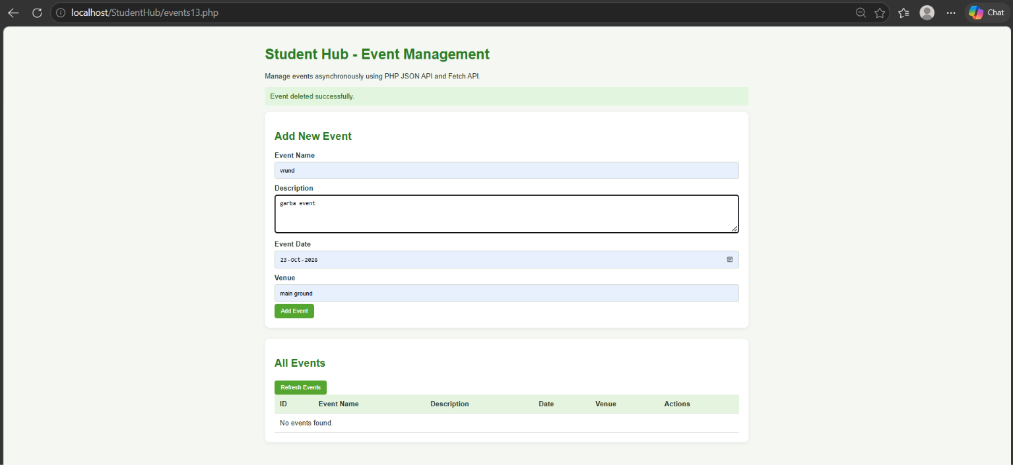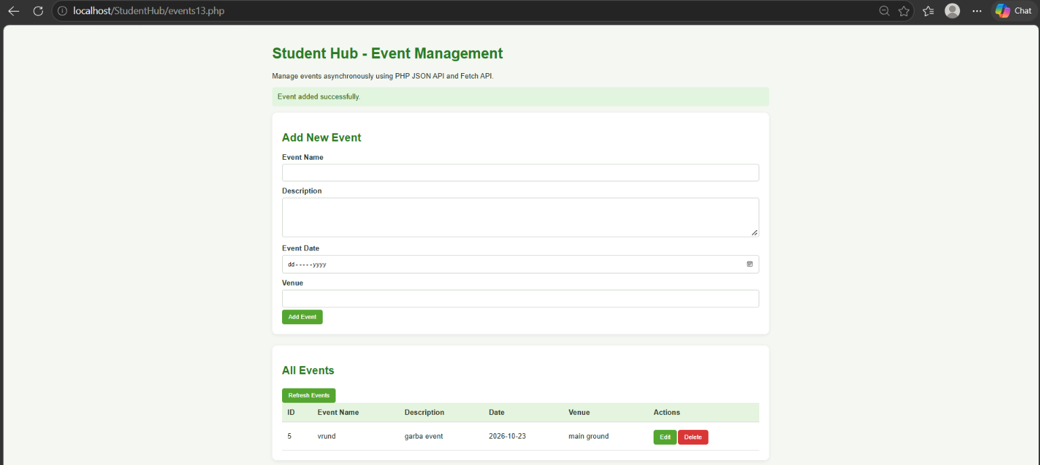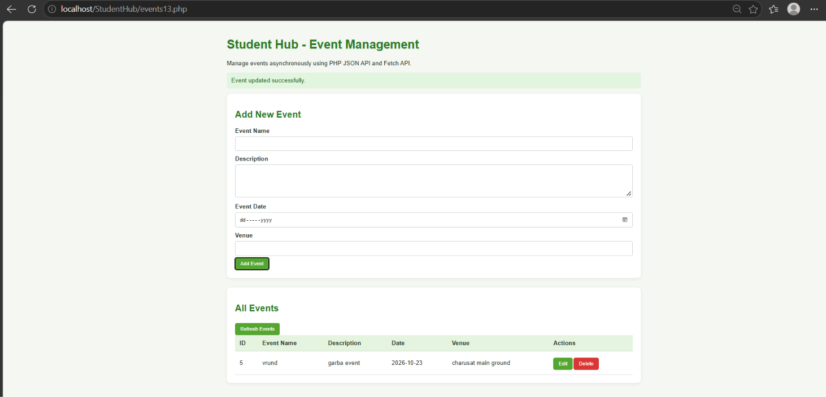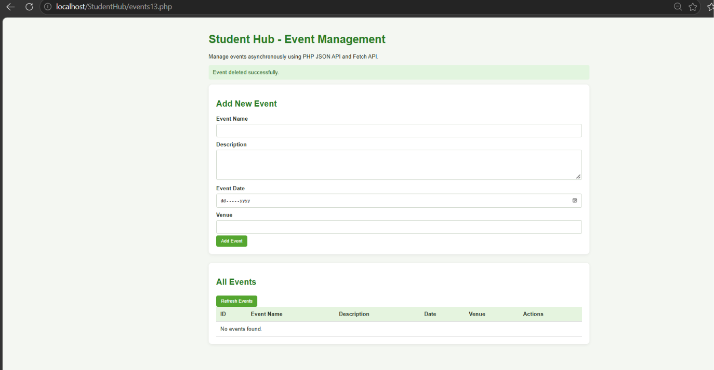
Github link:
https://github.com/kahanipatel156-dev/WDF-Batch-B/tree/main/Practical%2013

